March 2014
Ciara Thyfault
555.555.5555 cell
clthyfault@blank.com

Collin Shores
555.555.5555 cell
collinshores@blank.com

[Secure Proximity solutions (sps), LLC]
Confidential – The contents of this business plan have been submitted on a confidential basis. Do not copy, fax, reproduce, or distribute without permission.



Business Plan
Copy 1 of 1
Secure Proximity solutions (sps), LLC

Executive Summary

Opportunity
There are several threats to security these days from every angle. One of the most important threats is unauthorized access to data stored on workstations and servers. Most businesses now require their employees to lock their workstations when they are not in front of them. This simple but vital step is sometimes the only safeguard in place. It only takes one time where someone forgets or thinks that they will only be away for a moment for a cyber attack to take place. The ProxLock system provides an extra layer of security to the banking industry by helping to prevent unauthorized access to computers using a proximity based solution that will lock the workstation automatically when the user is away. In addition, the software will provide an audit trail to record who is making transactions and track efficiency in the workplace.

Market Size, Sales, and Marketing
Because banks have some of the highest risk associated with unauthorized computer usage, we are choosing to target this industry. There are over 1500 banks and credit unions in Kansas today. Our goal is to start with direct marketing to these banks to show them the value added by implementing our system.

Market Trends
While the economy continues to improve and cyber terrorism increases, the security industry is seeing positive growth rates as banks are reconsidering their security strategies. In addition, there are more and more cases of breach both from outside the bank walls as well as from within. The banking industry brought in a $76.6 billion profit in 2013 with an annual growth rate of 10%.

Team
Our team consists of Ciara Thyfault, Collin Shores, Adjete Mensah, and Qisheng He; all students in business and engineering majors at Wichita State University. Ciara brings marketing expertise as well as experience working for an organization that provided resources to entrepreneurs in Kansas. Collin works in IT and brings an understanding of information systems and technology paired with a finance background. Adjete has electrical engineering skills that will help innovate on current technologies. Qisheng provides programming talents required to deliver pioneering software to this project.

Financials

Secure Proximity Solutions is pricing our ProxLock solution at $30 each. With each unit costing $10 to produce, our break-even point is 850 units. We are projecting sales of 5,000 units in the first year and a growth of 30% per year after that. This is due to our plans to expand our target market drastically in each of the first 5 years.

Table of Contents

SECTION 1: Product Description

SECTION 2: Industry Analysis

SECTION 3: Marketing Plan

SECTION 4: Competition

SECTION 5: Management Team

SECTION 6: Financials

SECTION 7: Critical Risks

SECTION 8: Exit Plan

Appendix

SECTION 1: PRODUCT DESCRIPTION

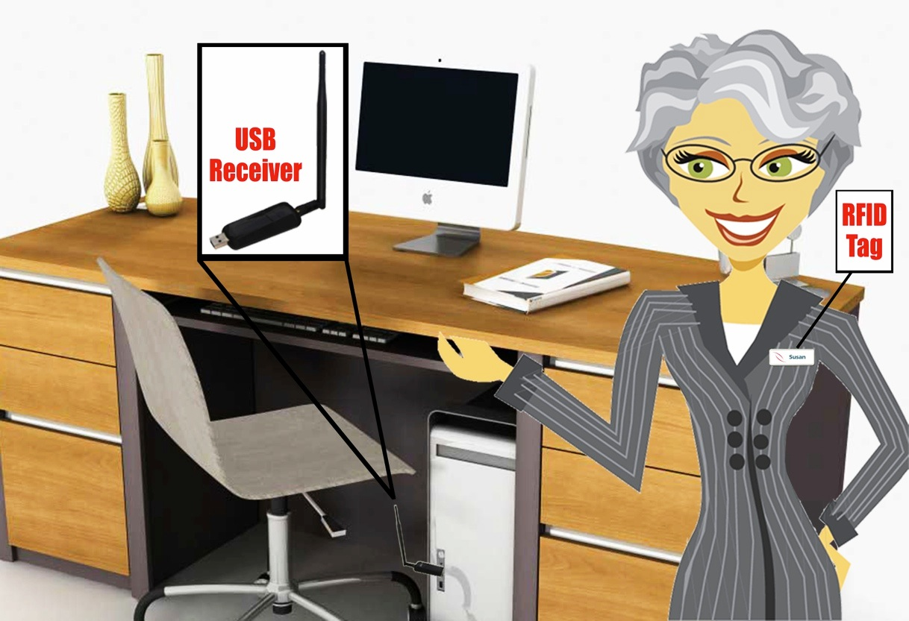

There are three major problems facing the banking industry today: high security risks, a need for accurate audit trails, and a lack of time efficiency. Workstations in banks have access to highly sensitive data. To protect this data, most bank employees today are required to lock their workstations as soon as they step away from them. This helps secure the workstation so that unauthorized individuals are unable to access them. However, bank employees are human and therefore not perfect. They sometimes forget to lock the workstations or choose not to because they think they will be right back. This leaves the bank vulnerable to a breech in security.

Banks also struggle to maintain accurate audit logs of who is really making transactions in the system and how long employees are working. Many teller machines are logged into one time and then used by multiple individuals. This makes it difficult to be sure who is to blame if a transaction is not entered correctly or if a malicious act is committed.

Finally, increasing time efficiency is a constant goal in this day and age. Banks try to speed up their processes to maximize productivity. Logging in and out of a workstation may not seem like a big drop in efficiency, but multiplied by several employees several times a day and it begins to add up quickly.
The ProxLock by Secure Proximity Solutions (SPS), LLC directly addresses each of these issues by automatically locking the workstation when the employee leaves the three foot proximity. Once the user returns within proximity of the workstation, they are prompted for a short and secure pin number to then log them back into their session.

This product includes three items; USB sensor, RFID chip, and downloadable software. Simply plug in the USB to the workstation. The USB then receives signals from the RFID chip that is attached to a sticker. The sticker is small enough to attach to the back of the teller’s nametag.

Finally, the software completes the audit trailing by tracking how many times the user leaves the proximity radius and logs off each user as well as how long the user has been logged on. The software can also be centralized to allow bank employees to use computers at different branches.

SECTION 2: INDUSTRY ANALYSIS

The ProxLock is categorized in the 56162 NAICS code. In this industry we can see a high profit to revenue margin following with new growth in the upcoming years.
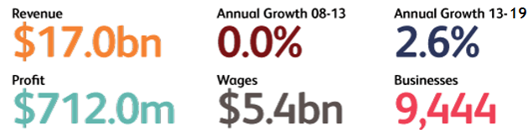
This graph shows the 2008 financial crash and how the industry is recovering and a promising future revenue outlook.
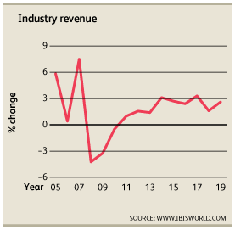
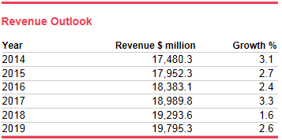
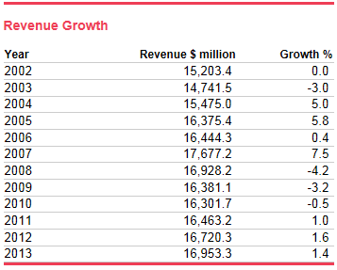
Finally, the statistics portray the approaching years to be profitable with a 2.6% annual growth rate, and approximately $500 million increase each year.

SECTION 3: MARKETING PLAN

There are currently over 1,500 banks and credit unions in Kansas. Our goal is to obtain a 50% market share in the first year of business. In year two, we are aiming to reach an 80% market share in Kansas as well as expand to the surrounding states (Colorado, Oklahoma, Missouri, and Nebraska). By the third year, we will go worldwide with our sales. We believe Kansas is a great initial location to begin direct sales because of the learning curve with this new technology. We also believe that the central location paired with our initial limited resources will give us a better chance of success. Once we have reached our worldwide sales we hope to minimize direct sales and rely mostly on online sales, which have higher profit margins.

Marketing Message: “Low cost effective solutions that saves you time and money!”

Our direct sales include:
- Trade shows
- Cold calls
- Finance industry journals
- Personal sales
- Website/web-store
- Direct mail
SECTION 4: COMPETITION

Competition for the ProxLock includes only few similar products on the market. We will focus on RFIdeas and XyLoc. Overall we have an advantage on the competition in simplistic product, affordable, and user-friendliness. Some competition also chooses to market toward the health care industry rather than banking. We feel that the banking industry will benefit from our product because tellers are already required to wear nametags and log off their workstation when they leave. This is an additional item to add to their already in place system to ensure security and efficiency.

SECTION 5: MANAGEMENT TEAM

The management team of SPS, LLC will consist of Ciara Thyfault, Collin Shores, Adjete Mensah, and Qisheng He.

Ciara, cofounder and Director in marketing, is a marketing major with strong organizational and social skills. These skills will be crucial in the startup phase of the business to obtain and maintain the market and customer relationships. She also has experience at NetWork Kansas where she and her team provided resources and knowledge to entrepreneurs in Kansas. These skills and connections will be vital during our start up phase.

Collin, cofounder and CFO, is an Entrepreneurship and Management Information Systems dual major with job experience in the IT industry. Collin has additional skills in the finance department providing our company leverage to determine the most sensible and lucrative decisions going forward. He also has experience working with RFID security solutions in the oil refining industry and an overall understanding of information systems and processes leveraged by various companies.

Adjete is a computer science and engineering student with skills in product development and electrical technology design. Adjete designed the RFID tag and sensors utilized by the ProxLock system.

Quisheng He is a computer science-engineering student who provides the programming expertise required to design the innovative software that will differentiate our product from others both now and in the future.

Our team is being counseled by an advisory committee staffed by two industry experts. Tim Miller has been at First National Bank of Hutchinson for over 16 years and is their Senior Vice President and Manager of their IT department. His career includes sitting on the Kansas Bankers Association Technology Committee Board and working as a programmer at Data Center Incorporated working on securing main frames. This expertise in the banking industry will give us a competitive advantage over most other entrants into this market. Also on the committee is Tim Collins, an IT Security Administrator and Koch Industries. Tim has decades of experience both with RFID security solutions along with a successful career of securing information systems with highly sensitive data.

SECTION 6: FINANCIALS

Our funding sources include $50,000 from the initial four team members as well as a $100,000 angel investment. These initial funds will be used to finish research and development of the product. We will also use this money to produce the first round of inventory and begin our marketing campaign. This initial burst of marketing will include direct sales as well as attendance of conferences and payroll of the sales team.

The pre-money valuation of our company is $500,000. This number was achieved by multiplying our second year sales by 2.5. As mentioned in the marketing plan, our sales are projected to grow 30% each year and our target market area will expand to the surrounding states in year two. This valuation allows our investors to get in on the ground floor of our company as we grow to net sales of over $400,000 in year five. We are offering a 20% stake in our company for the initial $100,000 investment.

Our engineers have quoted us a projected cost of goods sold of $10. Our goal is to price our system at just $30 each and hit sales of 5,000 units in the first year surpassing our break-even point of 850 units.

As shown in the following chart, our sales are projected at 5,000 units in the first year of operation and then growing by 30% each year after. We predict that once our target market reaches worldwide, there will be rapid growth after year 5.
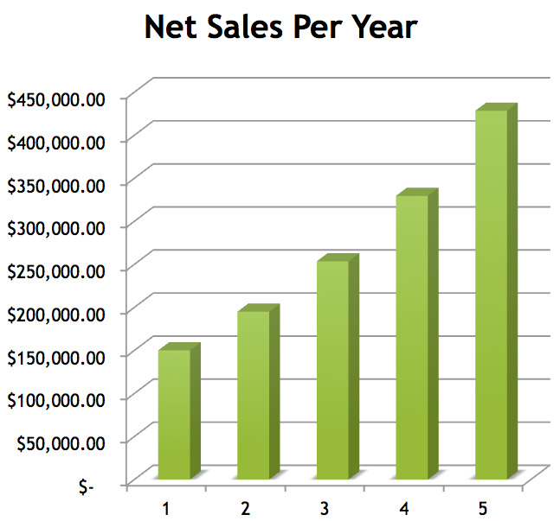

Our net income ratio is about .36 in the first five years due to our low cost of goods sold and operating expenses. This allows our income to have steady growth in the first years of operation.
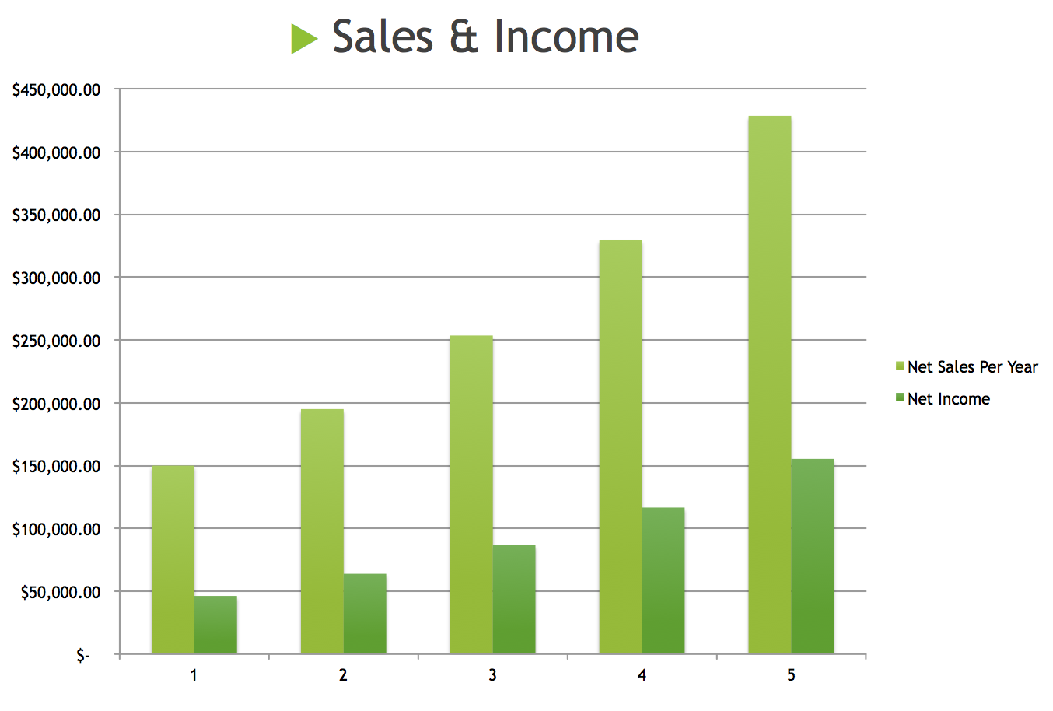

Full financial spreadsheet located in the Appendix.

SECTION 7: CRITICAL RISKS

While our product is still in the developmental stages we are sure that the most critical risk is reliability to be a true to its security breach. Additionally it is important to provide low costs to our customers. There are a few businesses with products similar to ours but they target their marketing focus to the health care industry. We have found that in health care there are even more crucial security needs. Our product is very basic, providing for lower costs not needed for health care but with enough of a value proposition for the banking industry.

SECTION 8: EXIT PLAN

Our goal is to gain additional investors to help achieve our rapid growth phase sooner. With additional capital, we could scale up our efforts and hire additional sales employees to spread our product faster. With a larger organization we could expand into other markets quickly and perhaps target a worldwide market by year 3.

After reaching a worldwide market we would like to achieve a high market share. Hopefully this would include our product being considered a standard tool in the industry or even perhaps inventing new technologies and processes that are patentable and become a must have tool for any organization.

Once we have achieved a stable market share in the banking industry, our goal would be to explore expanding into other industries and bringing our secure proximity solutions to other markets such as healthcare or education. This would help rapidly increase earnings by preventing market saturation in the banking industry.

At the end of the first five years, our initial team will consider if it is time to exit the business by either selling the company or going public. We will rely on the advice from our advising team as well as taking into consideration if we have gotten a decent return on our investments at that time.

Appendix

Detailed Financials:

Secure Proximity Solutions (in $thousands)
 | 2014 | 2015 | 2016 | 2017 | 2018
Income Statement
Net Sales | $150,000.00 | $195,000.00 | $253,500.00 | $329,550.00 | $428,415.00
Less Cost of Goods Sold | $50,000.00 | $65,000.00 | $84,500.00 | $109,850.00 | $142,805.00
Gross Profit | $100,000.00 | $130,000.00 | $169,000.00 | $219,700.00 | $285,610.00
Operating Expenses | $9,500.00 | $10,850.00 | $12,605.00 | $14,886.50 | $17,852.45
Depreciation | $1,000.00 | $1,300.00 | $1,690.00 | $2,197.00 | $2,856.10
EBIT | $89,500.00 | $117,850.00 | $154,705.00 | $202,616.50 | $264,901.45
Interest | $4.98 | $4.98 | $4.98 | $4.98 | $4.98
EBT | $89,495.02 | $117,845.02 | $154,700.02 | $202,611.52 | $264,896.47
Less Income Taxes | 35720 | $46,436.00 | $60,366.80 | $78,476.84 | $102,019.89
Net Income | $53,775.02 | $71,409.02 | $94,333.22 | $124,134.68 | $162,876.58
 | $0.36 | $0.37 | $0.37 | $0.38 | $0.38
Balance Sheet
Assets
Cash | $28,500.00 | $32,550.00 | $37,815.00 | $44,659.50 | $53,557.35
Cash Surplus/Deficit
Inventories | $7,500.00 | $9,750.00 | $12,675.00 | $16,477.50 | $21,420.75
Total Current Assets | $36,000.00 | $42,300.00 | $50,490.00 | $61,137.00 | $74,978.10
Gross Fixed Assets | $5,000.00 | $5,000.00 | $5,000.00 | $5,000.00 | $5,000.00
Less Accumulated Depreciation | $- | $(1,300.00) | $(2,990.00) | $(5,187.00) | $(8,043.10)
Net Fixed Assets | $5,000.00 | $3,700.00 | $2,010.00 | $(187.00) | $(3,043.10)
Total Assets | $41,000.00 | $46,000.00 | $52,500.00 | $60,950.00 | $71,935.00
 | $37,775.02 | $57,159.02 | $182,358.22 | $215,117.18 | $257,703.83
Liabilities and Equity
Accounts Payable | $22,500.00 | $29,250.00 | $38,025.00 | $49,432.50 | $64,262.25
Bank loan |  |  | $50,000.00 | $50,000.00 | $50,000.00
Accrued liabilities | $2,500.00 | $2,500.00 | $2,500.00 | $2,500.00 | $2,500.00
Total Current Liabilities | $25,000.00 | $31,750.00 | $90,525.00 | $101,932.50 | $116,762.25
Long Term Debt | $- | $- | $50,000.00 | $50,000.00 | $50,000.00
Retained Earnings | $53,775.02 | $71,409.02 | $94,333.22 | $124,134.68 | $162,876.58
Total Liabilities and Equity | $78,775.02 | $103,159.02 | $234,858.22 | $276,067.18 | $329,638.83
Cash Flow
Net Income |  | $71,409.02 | $94,333.22 | $124,134.68 | $162,876.58
Plus Depreciation |  | $1,300.00 | $1,690.00 | $2,197.00 | $2,856.10
Less Increase in Inventories |  | $2,250.00 | $2,925.00 | $3,802.50 | $4,943.25
Add Increase in Payables |  | $6,750.00 | $8,775.00 | $11,407.50 | $14,829.75
Cash flow from operations |  | $77,209.02 | $101,873.22 | $133,936.68 | $175,619.18

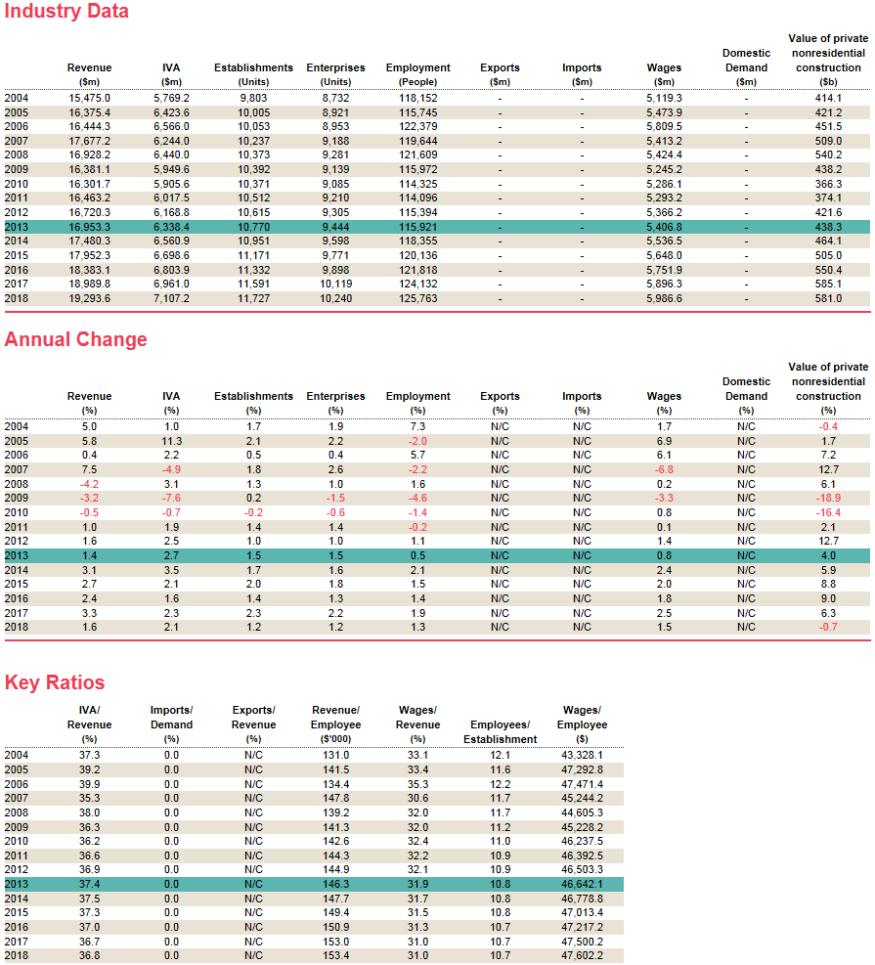

Customer/Consumer Interviews:
Collin:

- Charlie Beetch (end user)
  - I chose to interview Charlie because he is a teller at 1st National Bank of Hutchinson and has a business degree so he could communicate his opinion in a way that I was familiar with.
  - I asked Charlie about his daily routines, how he uses workstations, and the types of security measures and precautions his branch uses.
  - I learned from Charlie that bank tellers actually switch machines quite often throughout the days and also use workstations in the branch when not manning the drive through or walk up stations. He told me that they have complex passwords that change frequently and that they are required to wear nametags. He also told me that if you lock yourself out a machine because you forgot your password, it was a lengthy process to get it reset.
  - We didn’t make any direct changes from Charlie’s feedback, but we did take into account his comments about making it less painful to reset passwords in our software.

- Christy Neinstedt (end user)
  - I interviewed Christy while I was at my local bank branch discussing my car loan. She is a loan officer at Hutchinson Credit Union and has worked in the banking industry for over 20 years.
  - I mainly talked to Christy about the security risks associated with her workstation. She has an office and uses the same workstation all day. She told me that there is still a high risk of unauthorized use from someone in the branch. Her system has access to internal files and information that is for loan officers only. She told me that she is required to lock her workstation but admits that she frequently will forget to do so because she thinks she will only be gone for a moment. But some times these quick trips turn into longer ones and her computer is left vulnerable.
  - After speaking with Christy, we decided to have a shorter delay between loss of proximity and locking the workstation to prevent unauthorized entry. We also realized that banks might require more of our systems that just for the tellers.

- Mike Fahrbach (customer)
  - I was fortunate enough to talk to the senior vice president of First National Bank of Hutchinson while making a withdrawal from my local branch. He has been in banking since 1971 and ran the Haven branch (Bank Haven until 2010) for as long as I can remember.
  - I mainly asked Mike some big picture questions about the security risks he faces and how he works to mitigate them. I also asked him about his price sensitivity and what other considerations go into their purchasing decisions. He told me that they are very aware of the risks associated with the computers in their branch. But he admitted that since their branch is so small, they often side on convenience vs safety. He also told me that most of the employees had been there since before computers were available and weren’t exactly the most tech-savvy users. He thought that our system sounded simple and easy but worried about supporting them long term.
  - My main take away from my conversation with Mike is that our system had to be high quality and instill confidence from the consumers. We have been going for being a low cost option, but in the banking industry, they don’t exactly want to skimp on their security investments. Our system has to appear first class and 100% reliable to be adopted in the banking industry.

- Lori Cox (customer)
  - I conducted a phone interview with Lori who is the senior bank representative of operation s at 1st National Bank. She works to provide safekeeping services for bank customers.
  - I found out from Lori that banks are very concerned with security both for their sake and so that customers also feel that they are being protected. She liked the idea of our product and said that if bank customers saw that their bank was concerned about security enough to deploy such a system, the perceived security would make them feel more protected. She had concerns about setting up new employees as well and how the system would handle users from other branches, as they fill in at locations as needed sometimes. Overall she was very encouraging and thought that our price point was good however she wanted to know if there were bulk price points for banks purchasing several dozen devices.
  - My main take-away items were that we needed to look into bulk pricing as well as the employee setup process. I remembered Charlie mentioning that he often worked at multiple branches in Hutchinson, sometimes even within the same day. Our system might need to be able to be centralized to a point so that a bank could setup users at multiple branches. This complexity may increase the price and decrease the ease of use of our system.

- Julie Caffrey (Customer)
  - I spoke with Julie at a community function last month and asked her some questions about our concept. Julie is the Branch manager of the Hutchinson Credit Union branch in Haven.
  - Julie thought that our idea was very interesting and might solve a real problem in the industry. However, her branch only has three to five employees in the office at one time. She didn’t see a need to implement our system and deal with what she perceived to be “a lot of hassle” from a high tech solution. She told me that they don’t have any IT staff within 30 minutes and did not want to risk having someone locked out of their workstation while they wait for someone to come fix it. Julie told me that they do a pretty good job of locking their workstations and that she was comfortable with the security risks they currently face.
  - Speaking with Julie reminded me that our solution might not be right for every application. There is probably a point of diminishing returns at a point. Not every bank branch is going to find this solution appealing, especially those that are technology adverse or small enough to retain accountability.

Industry Expert Interviews:
Collin:
Tim Collins
My second industry expert interview was with Tim Collins who has been at Koch for several yeas and has decades of experience both with RFID security solutions as well as a successful career securing information systems that contain highly sensitive data. I know Tim from work where I regularly consult with him about security issues I come across in my job. He was instrumental in implementing the RFID security systems we have at our refineries across the country and has a deep understanding of these types of systems.
Tim wasn’t sure about our product idea at first. He had some trouble connecting to it’s practicality in the banking industry and tried to convince us to go with a more broad target market. But he then told us the story of Lennel, which is one of the vendors we use at Koch for our RFID systems. He told us that because of their focus on the refining industry, they have been able to provide unique and valuable solutions that are priceless in our operations. He thinks our system could adopt this method and gain high market shares in the banking industry.
He agreed with Tim Miller about centralizing the password information and encrypting it efficiently for large-scale implementations. This is similar to the method we employed at Koch with our refineries and it has saved them time and money implementing it at numerous sites. He was not sure we would be able to find an RFID sensor that would be powerful enough and small enough for the application we had in mind, but for a few more dollars than we expected, he found a solution.
Tim’s expertise is extremely rare and valuable when starting a project like this. We are lucky to have him on our advisory board and believe that his opinions and experiences will be a significant competitive advantage for us as we move forward with this business.
Tim Miller
For my first Industry Expert Interview, I spoke with Tim Miller, the Senior Vice President and Manger of the IT department at First National Bank of Hutchinson where he as been for over sixteen years. He was also on the Kansas Bankers Association Technology Committee Board and worked as a programmer at Data Center Incorporated where he worked on data security in main frames.
Tim explained to me the recent increased focus on security in the banking industry. They are being attached from every angle and therefore are working harder than ever to prevent breaches in security. They have been working on preventing attacks from the outside using firewalls and encryption. But they have also been hard at work minimizing security exposures from within the bank’s walls too.
After explaining our product to Tim, he had several insights into how we could improve our invention. He suggested having the RFID tag small enough to fit behind nametags, as not all bank employees have badges. He also encouraged us to provide solutions for large scale operations utilizing a database type architecture to allow for the security data to be stored centrally with more advanced encryption. This way if someone go ahold of one of the bank’s workstations, they couldn’t reverse engineer the password software.
Tim gave us a lot of good insight and tips on how to approach this market and develop the best fitting product for the banking industry. With his experience both in information technology as well as the financial world, he is a great sounding board for future ideas we may have for our project. He is also a great and valuable addition to our advisory board.

